Market Problem Analyze :

Risk from shopping via the internet:

1. Some of them often feel hesitatively to do online shopping due to lack of knowledge and experience of e-shopping.

2. Consumer's trust in online shopping or e-retailers is very tenuous.

3. There is a delay before receiving your package.

The first disadvatage is that there is no instant gratification. Because you have to wait a few days for the product is shipped to you.

4. You may receive an inferior product.Because you can't hold and look at it in your hands, you don't know the quality of the product. The discription or photograph of the product might be slightly different. As a result, you will get a inferior-quality item.

5. Shipping fee.Though products are generally cheaper in online store, however the addition of the shipping charge make the toltal price similar or more expensive than that.

6. There can be delivery problems.You may face delivery risks. the seller might fail to deliver the product you bought or it deliver a item that has been damaged during shipping.

7. There's a danger of being scammed.An online shopping will be easy become a target of online scams.

8. Some items are better to buy from the real store.it's best not to buy clothing products online because you won't be able to know whether they will look good on you

9.it's difficult to return items.Returning an item is more difficult when you shopping online. if your seller accepts returns, they will usually want the item within a short period of time, and you also have to pay for the shipping charges

10.Fraud and Security concerns.There are some other problems that can occur, such as credit/debit card fraud, spyware. Merchants also risk fraudulent purchases using stolen credit cards or fraudulent repudiation of online purchase.

11. Privacy of personal information.Buyer wish to avoid spam which could result from supplying contact information to an online merchant.

Market disadvantage:

Cash on Delivery is dominate payment method in Asia:

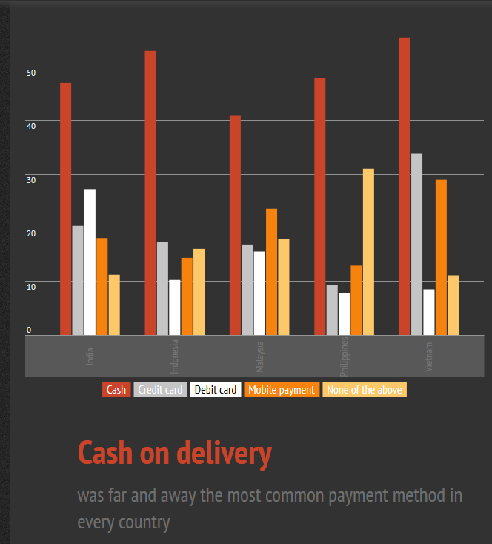source from: https://infogr.am/Online-Shopping-in-Emerging-Asia

Shopping online disadvantages per analyst by chart:

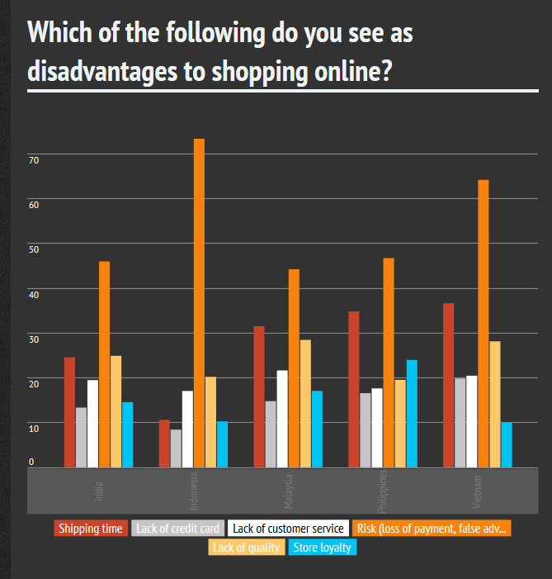

soucre: https://infogr.am/Online-Shopping-in-Emerging-Asia

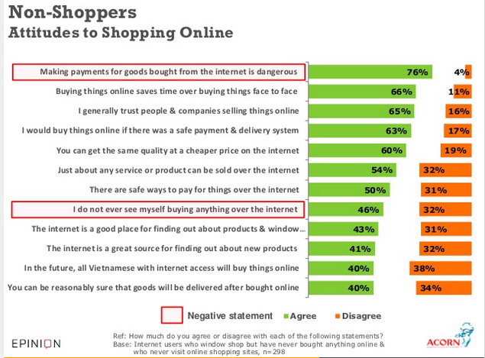

source: http://www.slideshare.net/reizarc/vietnamese-internet-users-online-buying-and-selling-behaviour

Summary:

- Two thirds of Vietnamese online shoppers access shopping site online and 45% do so on a desktop PC -only 22% use their smartphone and just 8% use a tablet.

- A staggering 88% have ever bought something online, with 20% claiming more than 25 purchase to date and a median of 8.75 purchases

-Average(median)spend on last item purchased was approx. VND 367,000(US$17.6), thought 8% said they spent over 5 million VND(US$240)

-But given poor access to credit and low bank usage in Vietnam, cash on delivery dominates e-commerce in Vietnam. Three quarters of last purchases were by COD to home and only 5% made by credit or debit card.

-Vietnamese online buyer feel comfortable buying online - with a plurality (38%) believing that online shopping is better than face-to-face shopping, while just 25% feel it is worse and two-thirds saying they will buy online again in future.

-Trust appears to remain a barrier among those who have never bought online three-quarters agree that making payments remains dangerous and less than half 40% agree that you can be reasonably sure of delivery if you buy something over the internet.

Source: **http://www.slideshare.net/reizarc/vietnamese-internet-users-online-buying-and-selling-behaviour**